Preface
For the purposes of convenience, I decided to temporarily put the “module-4” directory onto my desktop while I tested the codes. The final deliverable will follow the required file structure for the GitHub submission.
Project Overview: Sitka High/Low Weather Visualizer
This project is all about taking a basic, single-purpose weather script and turning it into an interactive Python tool for exploring weather trends. Using the 2018 Sitka, Alaska weather dataset (sitka_weather_2018_simple.csv), the program steps up from a plain data reader to a flexible command-line application that lets users choose what temperature data they want to view on the fly.
The original starter code was pretty straightforward: it opened the CSV file, pulled out the high temperatures, generated a quick plot using Matplotlib, and shut down. While it got the job done for a quick look at the data, it wasn't very flexible and didn't give the user any control over what was being displayed. The main goal here was to clean up that structure, make the code more modular, handle potential errors, and add an interactive menu loop.
To make this work, the data reading part of the script was expanded using Python's csv and datetime modules. Instead of just grabbing high temperatures, the code now pulls both maximum (TMAX) and minimum (TMIN) daily records, storing them alongside properly formatted dates. Converting raw text dates into real datetime objects keeps everything organized chronologically across the x-axis. Loading both highs and lows in a single pass also keeps things efficient so the program doesn't have to re-read the CSV every time the user picks a new option.
For the interactive side, the script uses a simple while loop paired with input validation. When you run the program, it gives you a clean menu to view daily high temperatures, view daily low temperatures, or exit. Choosing highs opens a line plot in red, while choosing lows displays the plot in blue. The charts also include a few quality-of-life touches, like automatically angled date labels so text doesn't overlap, gridlines, and clear titles.
To back up the code changes, two flowcharts map out how the program logic evolved. The first flowchart shows the simple line-by-line flow of the starter script, while the second models the updated program's menu loop, option logic, plotting function calls, and exit routine. Together, the updated script and diagrams show off a few key programming ideas, including brownfield development, basic menu design, error checking, and data visualization.
Part 1: The Original Program
Figure 1: Original Execution Flowchart
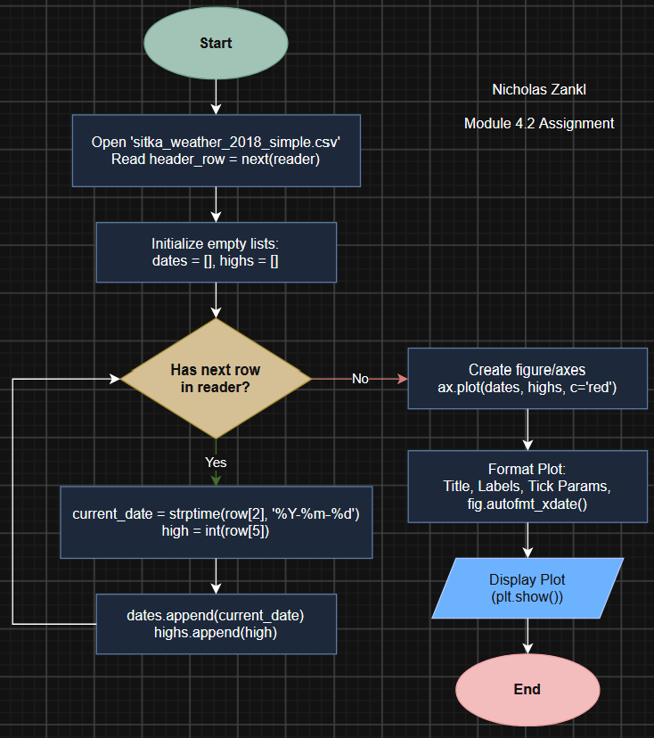
The starter program operates as a linear, single-pass script designed to extract and chart daily high temperatures from a local CSV dataset. It executes sequentially from top to bottom without any user prompts or conditional branching. The process begins by opening sitka_weather_2018_simple.csv and initializing Python's built-in csv.reader. To ensure data labels like DATE and TMAX do not disrupt numerical parsing, the script immediately calls next(reader) to bypass the header row.
Once the file structure is ready, the program initializes two empty lists for dates and high temperatures, then iterates line by line through the dataset. Inside this loop, it pulls the text date from column index 2 (row[2]) and converts it into a Python datetime object using datetime.strptime() so the timeline plots chronologically. Simultaneously, it extracts the daily high temperature from column index 5 (row[5]), converts the string value into a standard integer, and appends both parsed values to their corresponding lists.
After processing every row, the script passes the populated lists directly to Matplotlib's ax.plot() method to generate a single line chart rendered in red. It finishes by applying basic visual formatting, including custom title font sizes, axis labeling, and a call to fig.autofmt_xdate() to slant the date labels across the x-axis so they remain easy to read. Calling plt.show() pops up the completed graph and pauses the program until the user closes the window.
Figure 2: Daily high temperature image using the original code.
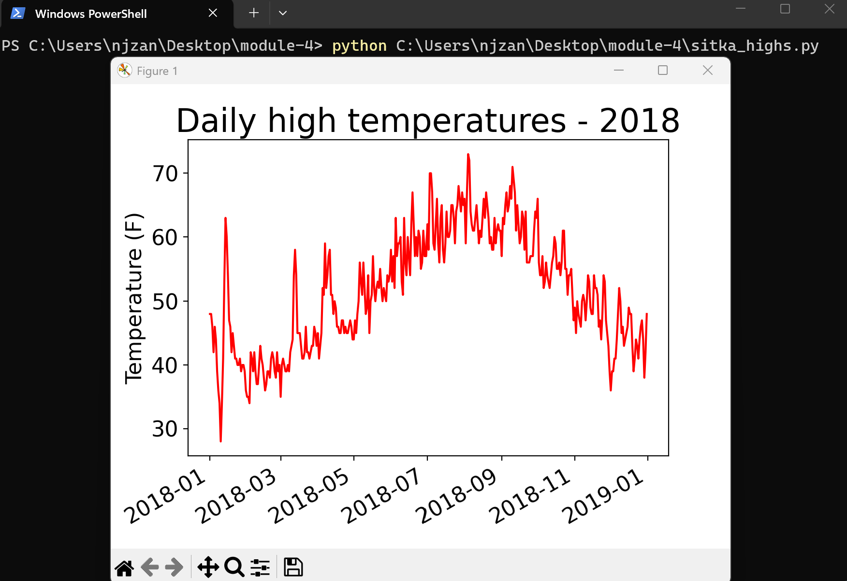

Part 2: Revised Program Mechanics and Enhancements
Figure 3: Revised Interactive Program Flowchart
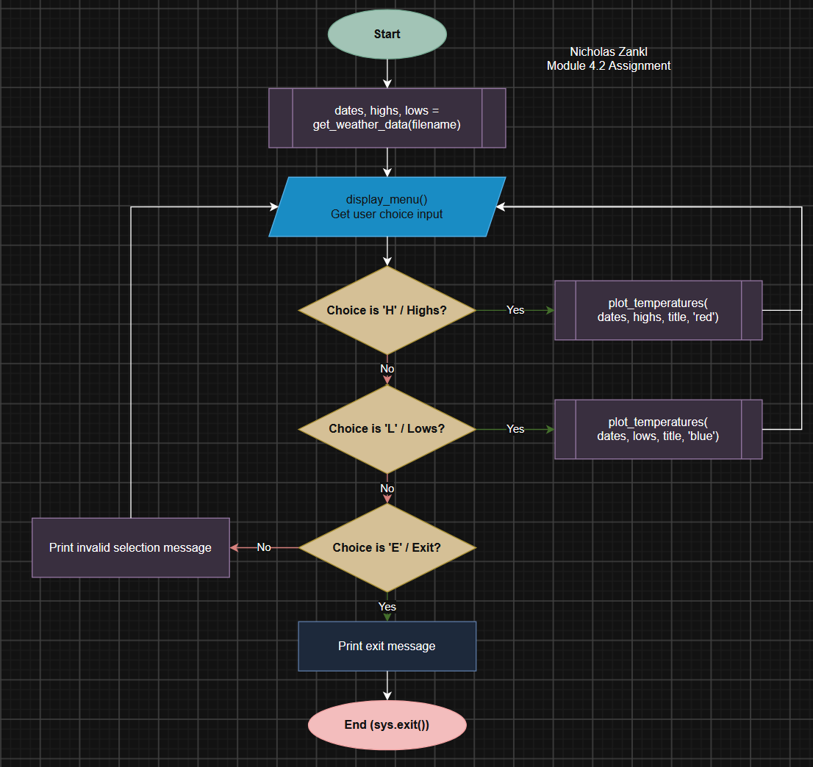
The updated program transforms the original linear script into a flexible, interactive command-line app built around a main control loop and modular functions. To make the code cleaner and easier to manage, the script is split into dedicated helper functions for loading data, showing menu options, and rendering charts.
The first major change happens during file reading inside get_weather_data(). Instead of only grabbing high temperatures, the code now reads column index 6 (row[6]) to collect daily low temperatures (TMIN) right alongside daily highs (TMAX). It also adds basic error checking, skipping corrupt rows and catching missing file errors so the program does not crash unexpectedly. All parsed dates, highs, and lows are saved into separate lists in a single file pass so the CSV only needs to be read once.
Once the data is loaded, the program enters a continuous while loop that keeps running until the user decides to quit. On each iteration, display_menu() prints out clear options for viewing daily highs, viewing daily lows, or exiting. The script uses if/elif/else conditional logic to process the user's choice. Selecting highs calls plot_temperatures() to display a red line graph, while selecting lows calls the same plotting function with the lows list to display a blue line graph.
Figure 4: Dynamic High Temperature Plot (Red)
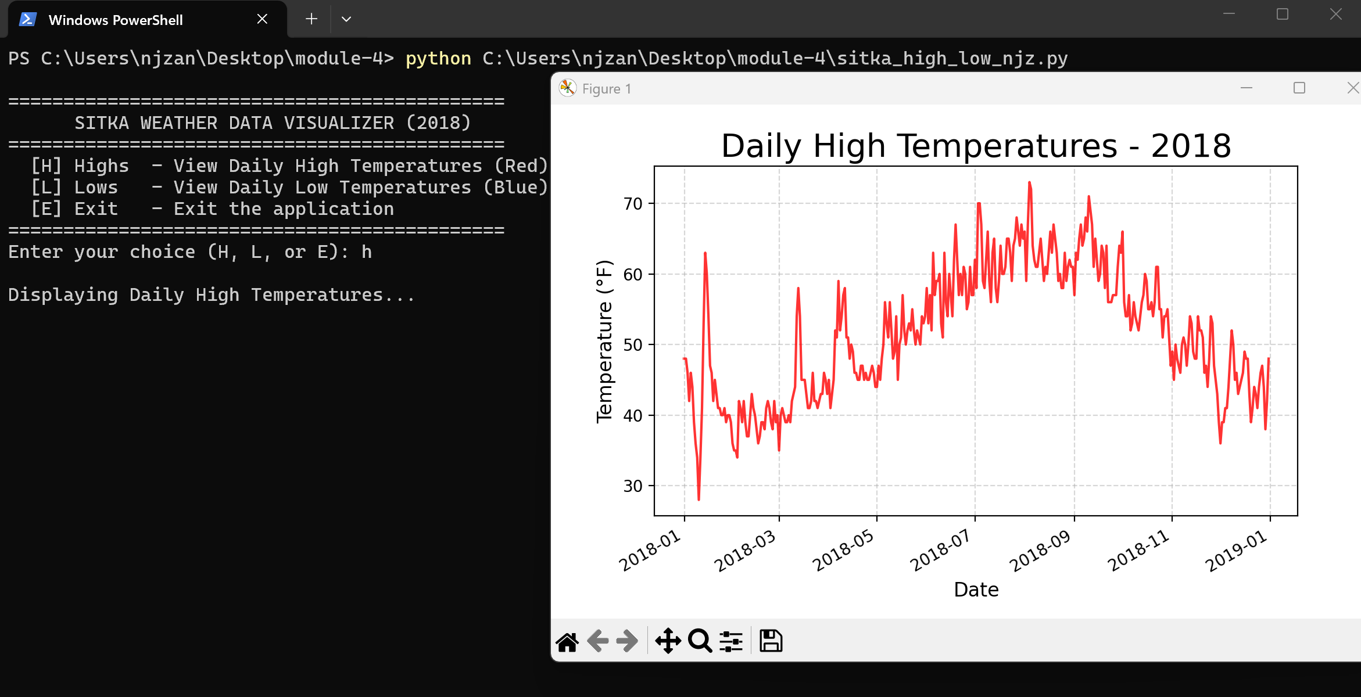
Figure 5: Dynamic Low Temperature Plot (Blue)
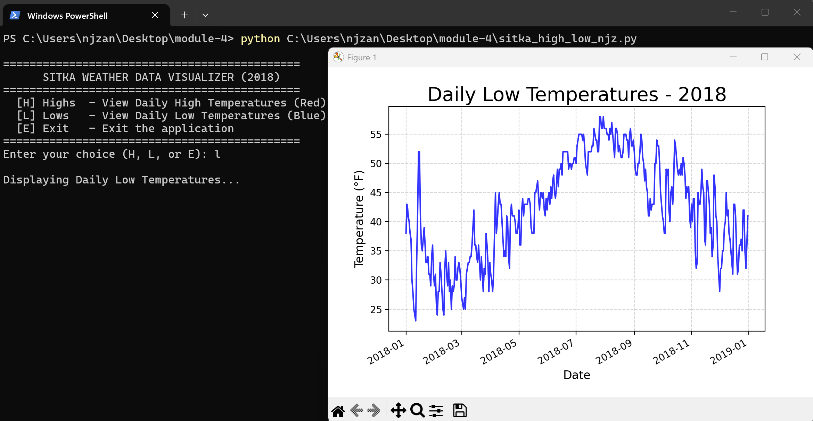
If the user types an invalid choice, the program prints a helpful warning message and loops right back to display the menu again.
Figure 6: Program Error Checking and Input Loop
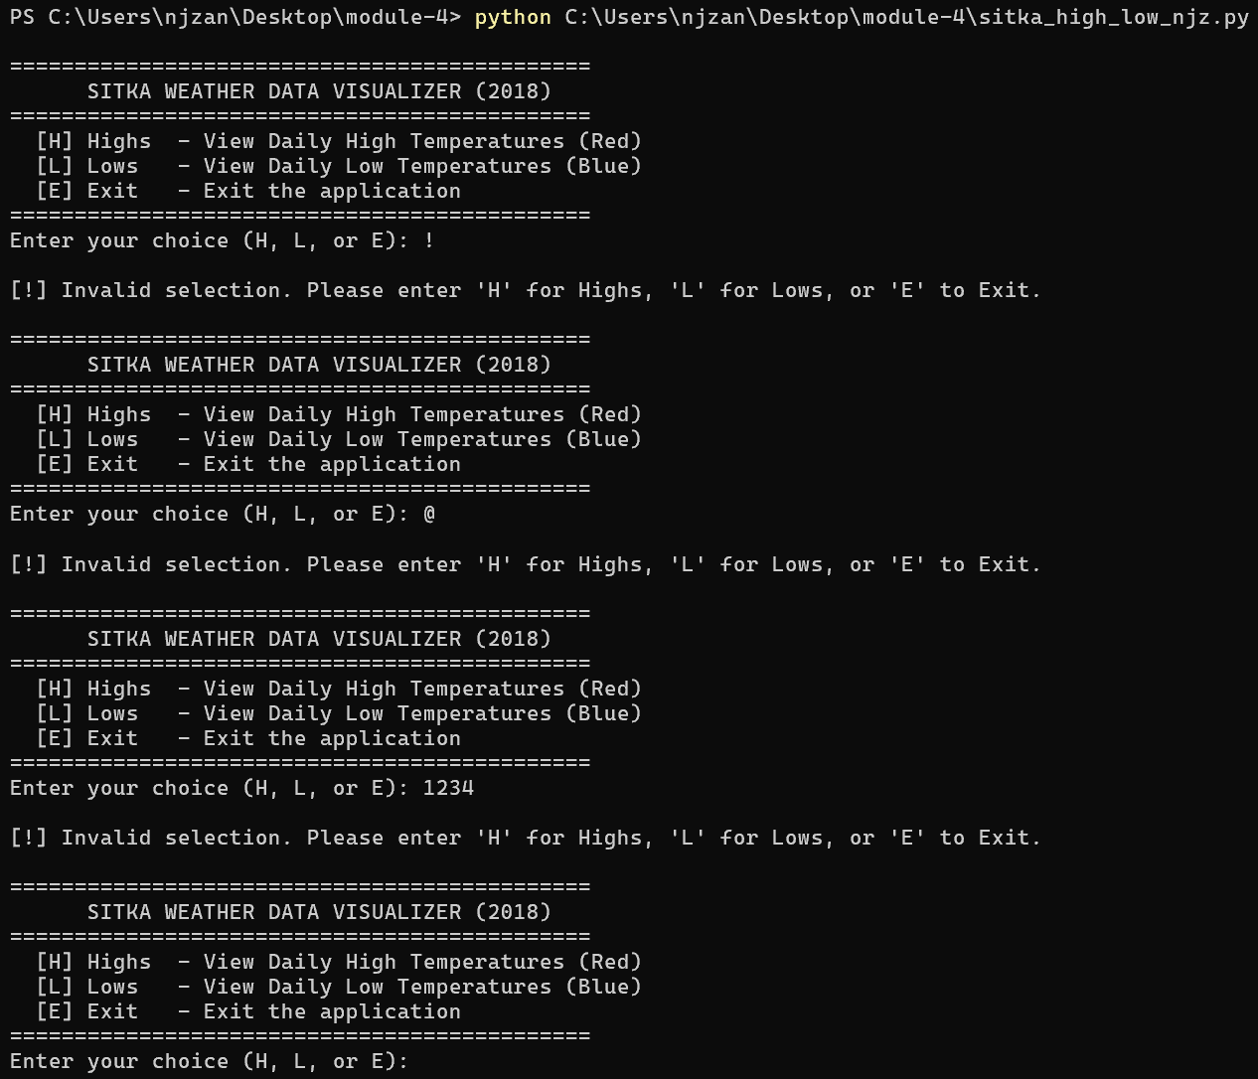
Finally, choosing the exit option prints a friendly closing message and calls sys.exit() to shut down the application cleanly.
Figure 7: Program Termination and Exit Message Output
